**AGILE Development in Cloud Computing Environments**

WS 2023-24



SERVICE MANAGEMENT COMPONENT

Project Members

|  |  |
| --- | --- |
| 1. *Theertha Bharathan* | *1445457* |
| *2. Soheil Nasiri* | *1324594* |
| *3. Farima Javadi* | *1428759* |
| *4. Kavya Hirebelaguli Chandrashekar* | *1429305* |
| *5. Pranil Prakash Ghadi* | *1441215* |
| *6. Richa Padhi* | *1438260* |

# Introduction

* **Overview of the Provider Management Platform**

This project aims to develop a Provider Management Platform (PMP) utilizing Agile principles. The platform serves as a space where job availabilities, along with detailed project descriptions, are shared. Providers, representing external companies with suitable employees, register and log in to view job availabilities. Providers enter details for selected profiles, awaiting evaluation by the portal's staff. Based on this evaluation, positive results lead to the issuance of offers, while negative outcomes pass provider data to new projects.

* **Service Management Component**

The Service Management Component is a critical module within the Provider Management Platform, focusing on the efficient management of IT service requests. This component enables users within the organization to initiate, track, and manage service requests for various IT services. It incorporates features such as creating service requests, evaluating offers from providers, and assessing the quality of services delivered. Additionally, the Service Management Component facilitates collaboration with providers and allows users to provide feedback on service delivery.

**Key features of the Service Management Component include:**

* **Service Request Creation:** Users can initiate service requests, including multi-requests and team requests, specifying details such as expertise level and required roles.
* **Request Status Tracking:** Users can monitor the status of the service requests they initiated, providing transparency and accountability in the workflow.
* **Offer Evaluation:** The component allows users to evaluate offers received from providers in response to service requests, enabling informed decision-making.
* **Collaboration with Customers:** Strategies are in place to collaborate effectively with customers to gather requirements and incorporate feedback during the service delivery process.
* **Provider Evaluation:** Users can assess and evaluate providers based on their performance and the quality of services delivered.

# Agile Methodology & its Principles

Agile is a flexible and efficient project management approach designed to bring products to market quickly. Agile projects are characterized by short intervals or sprints, allowing frequent adjustments based on requirements. The Agile process emphasizes pulling tasks rather than pushing, promoting faster adaptation and turnaround for workable products.

# Kanban Framework

Kanban, a Lean workflow management method, is employed in developing the Provider Management Platform. It visualizes work, maximizes efficiency, and improves continuously. User stories, representing project requirements, are assigned to developers and managed on a Kanban Board. This allows optimization of work delivery and handling complex projects in a unified environment.

# SCRUM as Agile

Scrum, another agile framework, structures and manages work through principles and practices. It breaks projects into manageable "Sprints." The Scrum master plays a pivotal role in understanding engineers' availability, clarifying project requirements, and organizing user stories into sprints. Frequent meetings with the customer and integrations with different teams ensure continuous progress.

# Database

Data is stored using MongoDB, a database known for building highly available and scalable internet applications. MongoDB's flexible schema approach aligns well with agile development, allowing immediate application building without extensive database configuration.

# Sprint Planning

Sprint Planning is a crucial event in Scrum, defining deliverables for the upcoming sprint and outlining the work plan. The steps involved in Sprint Planning include:

Reminding the team of the big picture or goal.

Discussing any new information impacting the plan.

Confirming team capacity and addressing known issues.

The Product Owner answering questions and elaborating acceptance criteria.

This process ensures a clear understanding of project goals and efficient planning for each sprint.

# Sprint 1 (Length - 1 week)

During this sprint, the team received information about the technology chosen by the client, Professor Wacht. The project requirements were outlined and distributed. Following the Agile principle, we acknowledged the likelihood of changes, and occasionally, a given requirement might be shifted to the backlog for the next sprint. With the requirements established, our focus shifted to project planning and selecting the appropriate platform. Notably, the client expressed satisfaction with any coding technology. To facilitate effective management, the requirements were divided into user stories, each assigned to developers with an estimated time frame for completion.

# Sprint 2 (Length - 1 week)

Building upon the foundational work in Sprint 1, Sprint 2 for the Service Management Component focused on the implementation of the service request functionality. The team concentrated on developing an intuitive user interface to allow users to create diverse service requests, including single requests, multi requests, and team requests for IT services. Concurrently, the team initiated the integration of specifications such as expertise levels and roles to meet user requirements.

# Sprint 3 (Length - 1 week)

Sprint 4 was dedicated to advancing the Service Management Component's capabilities. Users gained the ability to initiate multiple cycles (up to two) for a single request, enhancing flexibility and accommodating evolving project dynamics. Concurrently, the team commenced the implementation of the evaluation system, enabling users to assess and provide feedback on the offers received.

# Sprint 4 (Length - 2 weeks)

Sprint 4 was dedicated to advancing the Service Management Component's capabilities. Users gained the ability to initiate multiple cycles (up to two) for a single request, enhancing flexibility and accommodating evolving project dynamics. Concurrently, the team commenced the implementation of the evaluation system, enabling users to assess and provide feedback on the offers received.

# Sprint 5 (Length - 2 weeks)

Sprint 5 marked a crucial phase where the team concentrated on optimizing user interactions and refining the evaluation process. In addition to the planned features, the team incorporated a pivotal task - integration with APIs from other groups. This involved establishing connections to external groups, enabling users to access provider offers seamlessly. Concurrently, users gained the ability to select profiles from received offers that best matched their specified requirements. This sprint highlighted the Agile approach's adaptability, fostering continuous improvements based on real-time user feedback and external API integrations.

# Sprint 6 (Length - 1 week)

In the final sprint, Sprint 6, the team focused on finalizing end-to-end functionality for the Service Management Component. In addition to user evaluations and feature enhancements, the team addressed another critical task - integrating with external APIs. Specifically, the team worked on integrating APIs for authentication components, ensuring users could log in securely. Collaborating with other groups, the team successfully established connections to external authentication services. This comprehensive approach aimed not only to deliver a robust user experience but also to seamlessly integrate with external systems and services. As the project concluded, collaboration with the customer intensified to ensure the final specifications aligned seamlessly with user expectations and external API integrations.

# Sprint Meetings & Review

Sprint Meetings and Reviews play a crucial role in the Agile methodology, providing opportunities for collaboration, assessment, and adaptation throughout the development process. In these iterative cycles, the project team comes together to discuss progress, and challenges, and plan for the next steps. Sprint Meetings typically commence each sprint and are characterized by the following components:

* Sprint Planning: At the beginning of the sprint, the team collaboratively plans and prioritizes tasks, determining what can be achieved during the upcoming iteration.
* Daily Stand-ups: Short, daily meetings where team members share updates on their work, discuss impediments, and coordinate efforts. These brief sessions foster communication and keep the team aligned.
* Sprint Review: At the end of each sprint, a review session is conducted to showcase the completed work to stakeholders. This session includes a demonstration of the deliverables, facilitating feedback and adjustments.
* Sprint Retrospective: Following the review, the team reflects on the sprint, discussing what went well, what could be improved, and identifying action items for continuous enhancement.

Sprint Meetings ensure transparency, effective communication, and alignment among team members. They enable the team to adapt to changing requirements, address challenges, and continuously deliver value. Regular reviews during these sprints ensure that the project aligns with stakeholder expectations and remains on track for success.

Fig 1: Sprint Meetings and Reviews

# PMP Architecture

Fig 2: PMP Architecture

# A diagram of a flowchart Description automatically generatedPMP Flowchart

Fig 2: PMP Flowchart

# Provider Management Platform (PMP)

The Platform is available at : the URL address [here](http://16.171.8.14:8000/)

This platform serves as a central hub for providers to engage with available candidates through open master agreements.

## Home Page

Our home page serves as the gateway to Service management, providing a concise overview of the Create Request, Request Status, and Offers. Curious to know who's driving the innovation behind the scenes? Our "About Us" section sheds light on the engineers and contributors responsible for shaping the Page.

## 

Fig 3: Home Page

## Register /Login Page

Accessing Service Management Page is a streamlined process through our Registration and Login Page. To participate in the platform, clients are required to register and log in. The registration page offers a straightforward sign-up experience, featuring fields for username, email, password, and a category field. A single click on the 'Sign Up' button initiates the registration process.

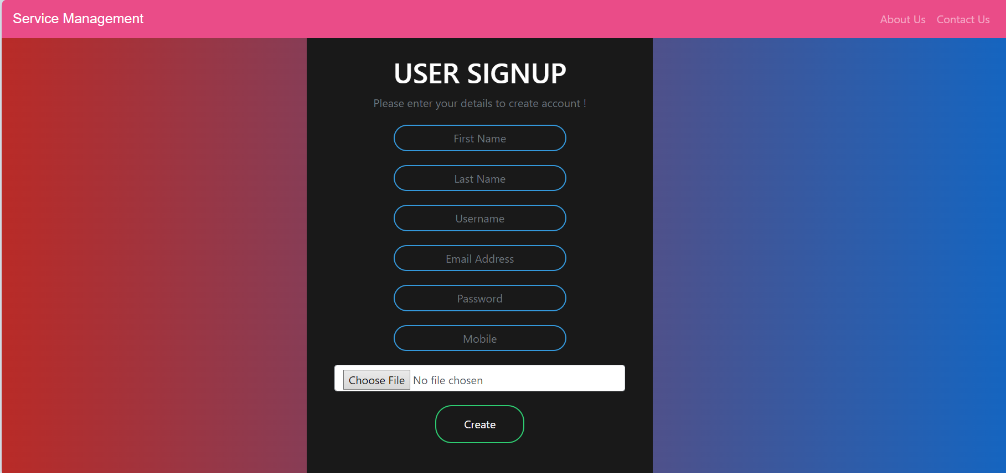

Fig 4: Signup page(integration with group 1)

## Create Request

The "Create Request" page in this project's Service Management Component serves as a user-friendly interface enabling providers to initiate various types of service requests for IT services. Users can specify the nature of their requests. The page facilitates the inclusion of detailed requirements, such as desired expertise levels and specific roles needed for the requested services.

## Request Status

## Offers

# API of Service Management Component

## Post

The API is available [here](http://ec2-54-166-224-107.compute-1.amazonaws.com:9198/api/v1/serviceManagement).

